

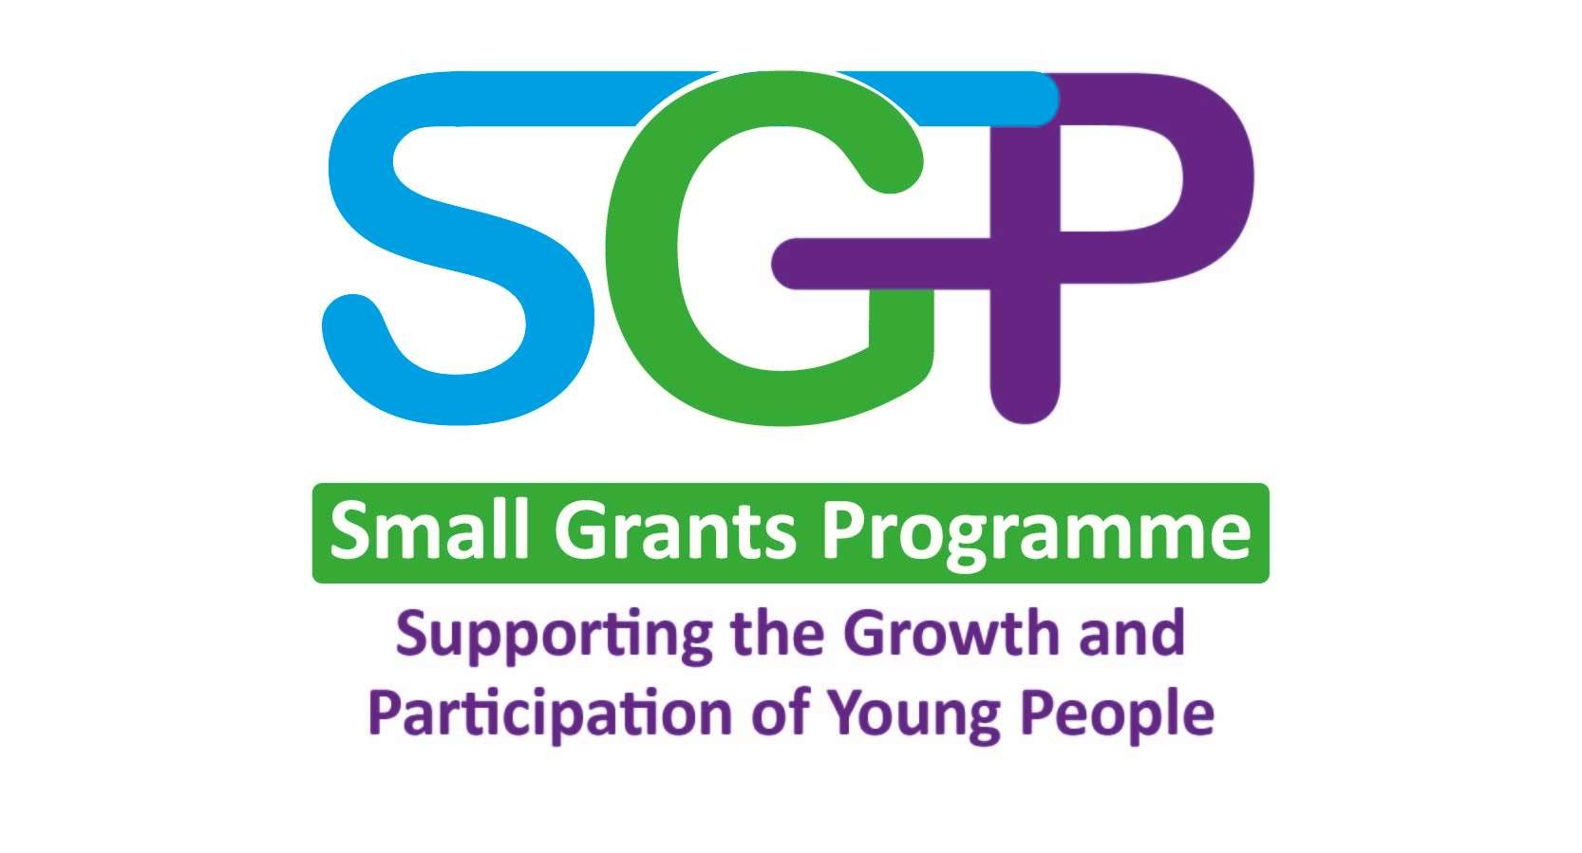
Small Grants Programme 25-26
Application Form

The Small Grants Programme 2025-2026 is to enable young people to apply for funding to support young people in their communities to:
- promote youth participation, leadership, and volunteering.
- build and develop life skills.
- explore relevant issues for young people (This could include relevant issues in your area or a key area of focus identified in the Regional Assessment of Need).
When completing this form, please read through the accompanying guidance notes. This will give more information on the purpose of the programme for this year along with key information to assist with completion of the application form. If you have any questions or need any help, call us on (028) 9047 6701 or email sgp@eani.org.uk

Contact Details (young person)

Full Name |  | Age
Address (of your Youth Organisation/Youth Club) | Postcode:
Contact phone number

Mobile number (if applicable)
Email address (this should be an email address you use and check regularly)

The contact person should be a member of the youth group applying for the grant. This will be the person we contact regarding the application (any contact will be prearranged with the youth leader). In a small number of cases this may not be possible and another person, for example, a youth worker or volunteer, is needed to act as the contact person. If this is the case, please explain why in the space below and submit along with the application form evidence of the group planning the activities e.g. Photos of group work or planning sheets

Youth Organisation Details:

Youth Organisations must be Education Authority Youth Service registered and verified. (See guidance notes for the role of the Youth Organisation)

Complete the details below of your Youth Organisation and the leader who will support your project.

Name of Organisation
Full Name
Position in Organisation
Contact phone number
Mobile number

Email address
Are you registered with EA Youth Service? (tick) |  | Yes |  | No

Project Details:

Are you applying for: (please tick)
Option 1 - Group programme  Maximum award £1500 |  | Option 2 - One off event  Maximum award £500

Project Name

Please confirm number of children/young people making the application?
(Please note a minimum of 3 young people must make the application)

Please provide the number of young people against each age range who are directly involved in making this application:
4-8 years |  | 9-13 years |  | 14-18 years
19-21 years |  | 22-25 years

How many young people will be taking part in the overall project?

Please provide the number of young people against each age range who are taking part in the overall project
4-8 years |  | 9-13 years |  | 14-18 years
19-21 years |  | 22-25 years

Project start date |  | Project end date  (All projects should end by  31st December 2026)

Question 1: Project Impact

Why is your project needed and what impact will it have?
(Why is it needed? How will it address local issues? What difference will it make? Will it increase partnership working and diversity?) Please see guidance notes for additional details

Maximum 300 words

Question 2: Project Outline
Please provide an outline of your sessions or event in more detail and how you will accomplish your goals. Please also highlight how your programme will meet the needs of young people and how it fits into the themes of the Small Grants Programme.
Outline of your project and what will be achieved in each session | Dates delivered

Question 3: Project Rationale

What do you want to achieve from this project?
(What is the overall aim? How does in fit into the purpose and themes of SGP? What are the outcomes?) Please see guidance notes for additional details

Maximum 300 words

- What is the overall aim of your project?
- How does the project fit in with the themes and purpose of Small Grants Programme?
- Why do you think your project is needed?

Question 4: Value for Money

Please state how your project represents good value for money.
(Ratio of staff and volunteers to young people, rationale for employment of specialist staff, in kind contributions where others see value of the project.) Please see guidance notes for additional details

Maximum 300 words

Question 5: Project Costs
SGP Project Costs 2025-2026
How much is your project going to cost and how much will you need from Small Grants? Please itemise each cost below.
Please see pages 5 and 6 of the Guidance notes for what can and cannot be funded.
Category | Detailed Breakdown/ Calculation of Cost | Per hour costs (If applicable) | Total Amount (£)
Activities
Materials/Resources (Max £400)
Equipment – EXCLUDING ICT/ Audio/ Visual (Max £400)
Please outline the longer-term, sustainable benefits of the purchase:

Specialist Facilitators (Max £25 per hour)
If cost is more than 20% of total project cost, please outline why it is not possible to deliver the project without specialist facilitators:

Catering (Max £4.00 per person for events/activities under 5 hours and £8.00 per person for over 5 hours)
Transport
Hire of Venue
 | Total |  | £

Amount Required from SGP per head

Total amount | Number of overall participants | Amount per head | Max allowed
 |  |  | £80 per head

Declaration and Consent (by applicant)

I declare that the information provided in this application form is accurate.

Contact person’s Signature |  | Date
Sponsor organisation Signature |  | Date

Returning Applications

Hard copies of Applications can be returned to: Youth Service Small Grants Programme, Education Authority, Grahamsbridge Road, Dundonald, Belfast, BT16 2HS.

OR:

Applications may be submitted by email to: sgp@eani.org.uk

Remember to keep a copy of your completed application form for your own records.

Small Grants Programme Applications for 2026-2027 will launch on 26 January 2026 and the closing date will be 23 February 2026 by 4pm.
Applications received on or before 23 February will be assessed with the outcome notified by the 31 March 2025.

Project must be completed by the 31 December 2026.

