Wild Youth Award - certificate request form
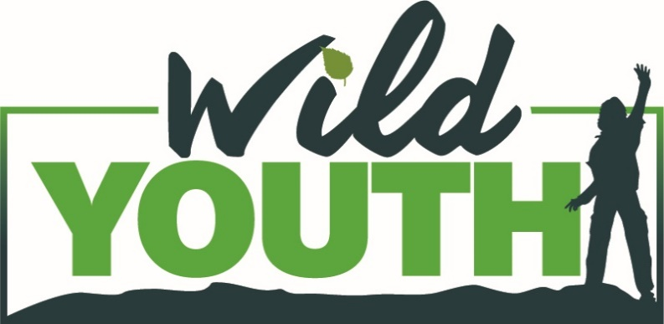

Name of Youth Group
Youth Worker
Contact telephone number
Contact email address
Short description of your social action project including when and where it took place.
Number of certificates needed - Award based on number of hours a young person has participated in action for the environment. | Bronze (at least 12 hours): _______  Silver (at least 25 hours): _______  Gold (at least 52 hours): _______
Address certificates to be posted to
Please email to info@ulsterwildlife.org

